Map for Division Gyms, Hotels, Social and Hospitals
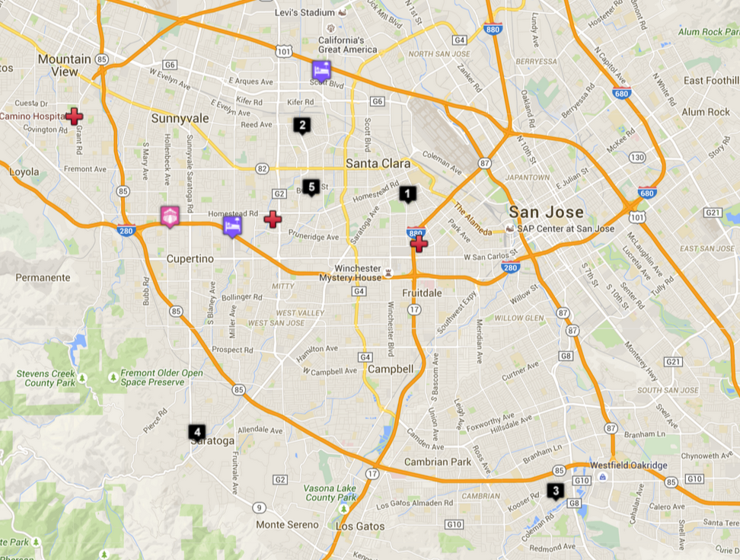
 | Buchser Middle (B8)  1111 Bellomy St Santa Clara, CA 95050 |  | Saratoga High (B12)  20300 Herriman Ave Saratoga, CA 95070
 | Wilcox High (B7, B9)  3250 Monroe St Santa Clara, CA 95051 |  | Santa Clara High (B11)  3000 Benton St, Santa Clara, CA 95051
Pioneer High (B10)
1290 Blossom Hill Rd San Jose, CA 95118
 | Hilton Garden Inn Cupertino  10741 N Wolfe Rd Cupertino, CA 95014 |  | Embassy Suites Santa Clara - Silicon Valley  2885 Lakeside Drive Santa Clara, CA 95054
 | Homestead Bowling Center  20990 Homestead Rd, Cupertino, CA ‎  (408) 725-0888
 | El Camino Hospital  2500 Grant Rd, Mountain View, CA ‎  (650) 940-7000 |  | Kaiser Permanente Santa Clara Medical Center  700 Lawrence Expressway, Santa Clara, CA ‎  (408) 851-1000 ‎
O'connor Hospital
2105 Forest Ave, San Jose, CA ‎
(408) 947-2970

